Student Name: 黄敏 HuangMin  
Email: huangmin@asu.edu  
Submission Date: 2024/4/7  
Class Name and Term: CSE 534 Spring B

Project2 part1报告

# 项目概述Project Overview

本项目通过在gateway上配置防火墙，实现了client/server/gateway集群与公网隔离，保证只允许好的流量可访问，在client访问gateway网关ip，端口请求转发到server，server通过gateway响应请求。

# 网络配置Network Setup

绘制一个网络图来表现你搭建的虚拟网络，需要包括以下内容Draw a diagraph and provide descriptions about the network setup, include:

* 网络拓扑topology,

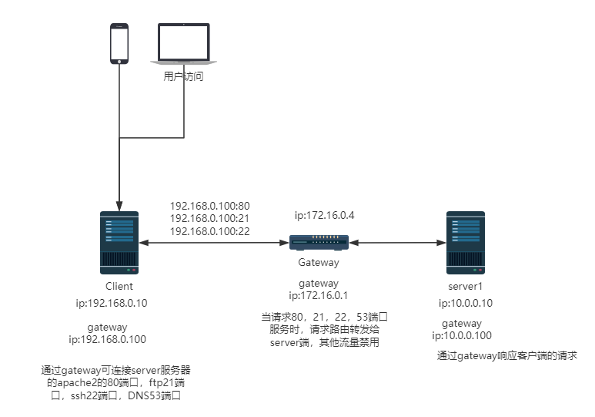

* 网络配置，如虚拟机的IP等，network configurations (IP addresses, etc.)

client的ip是192.168.0.10，如下是ifconfig和router

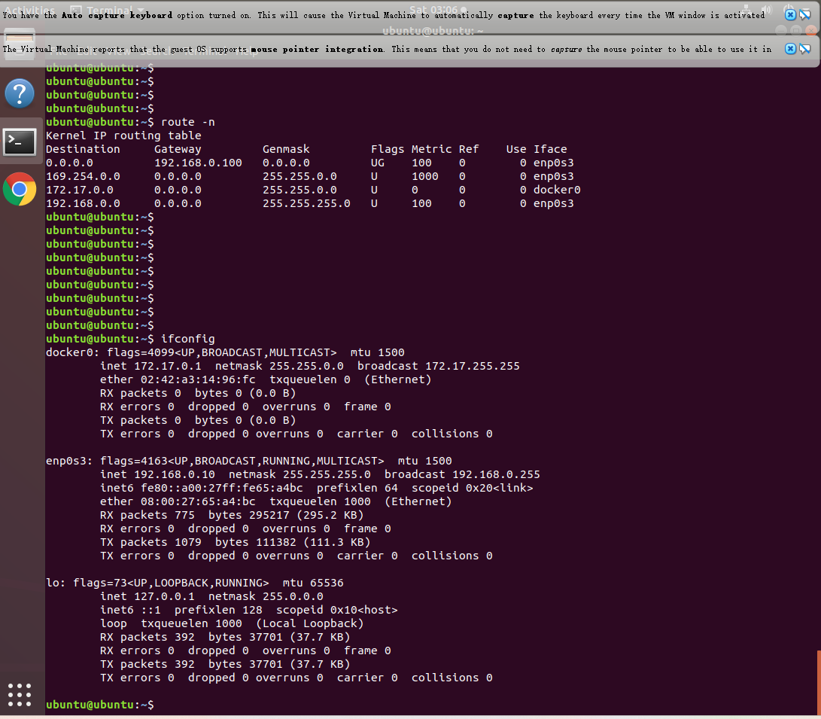

server的ip是10.0.0.10，如下是ifconfig和router

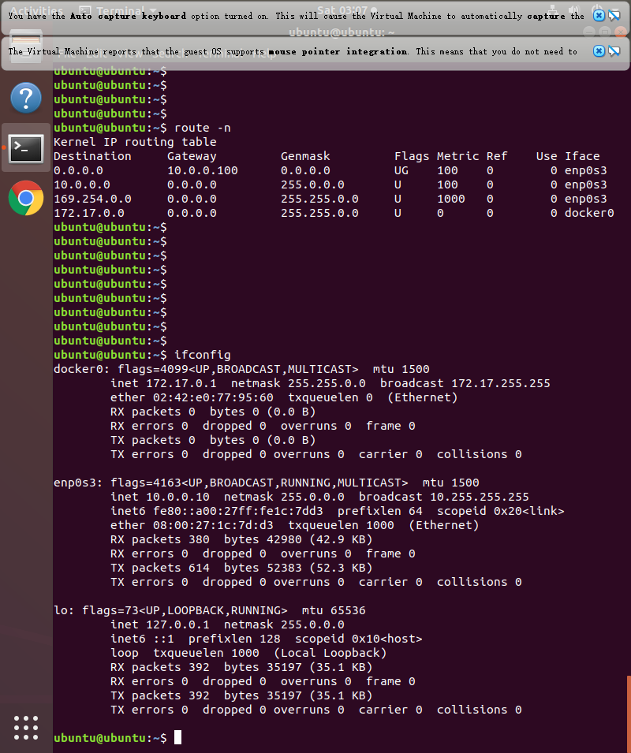

gateway的ip是172.16.0.4，如下是ifconfig和router

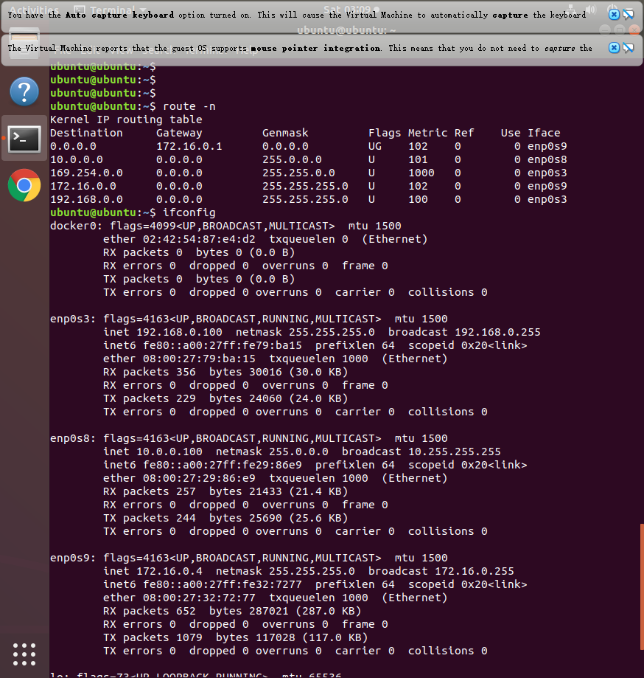

* 虚拟机之间的连接状况initial reachability among network nodes ，在防火墙为黑名单的初始阶段，各个虚拟机之间互相能ping通

Client和server ping gateway

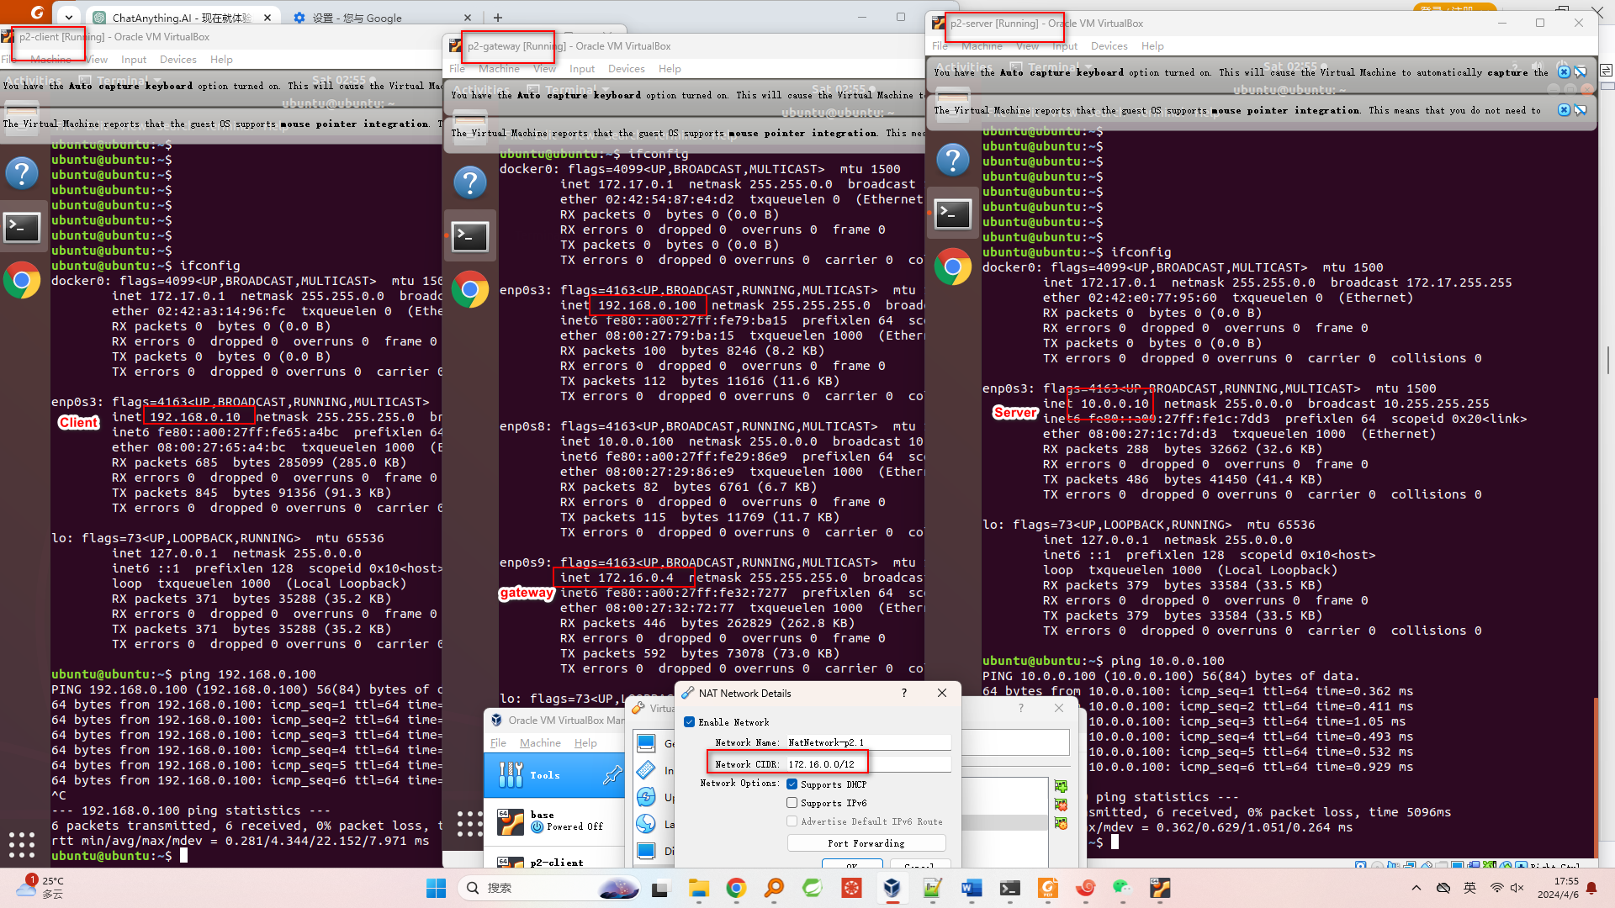

client ping server和公网DNS

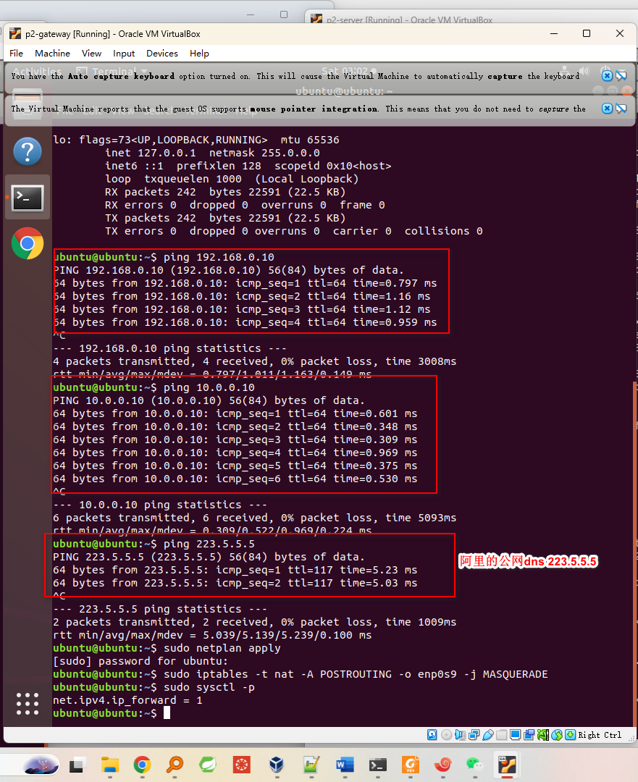

Server ping 公网dns和client

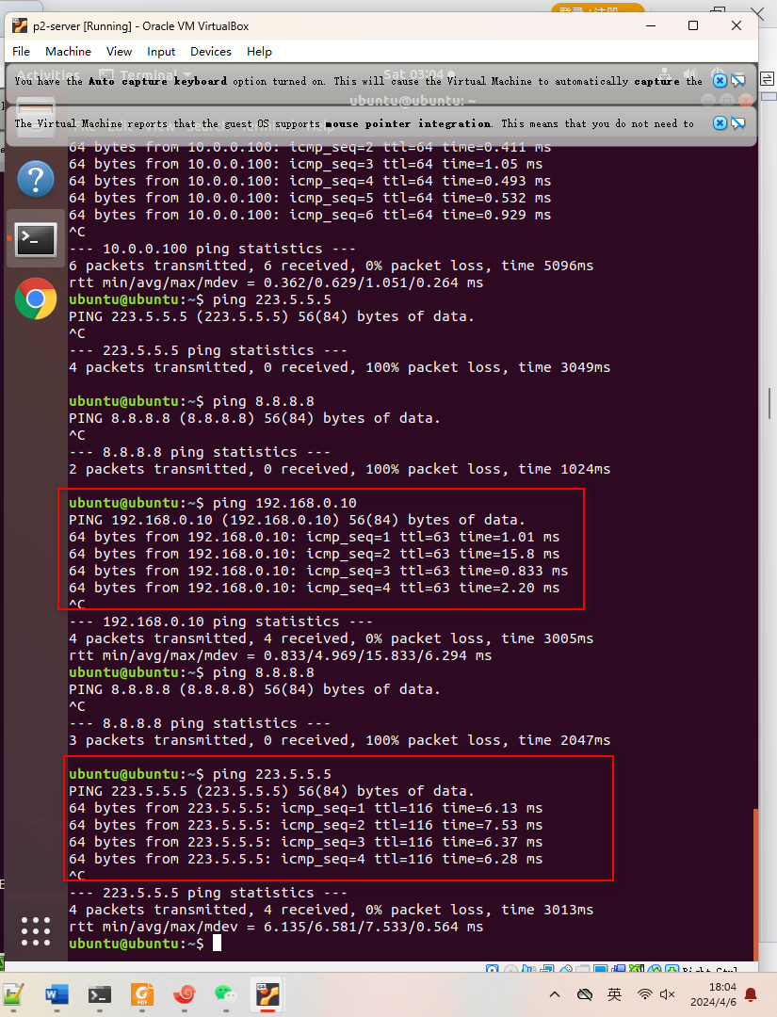

gateway ping client和server

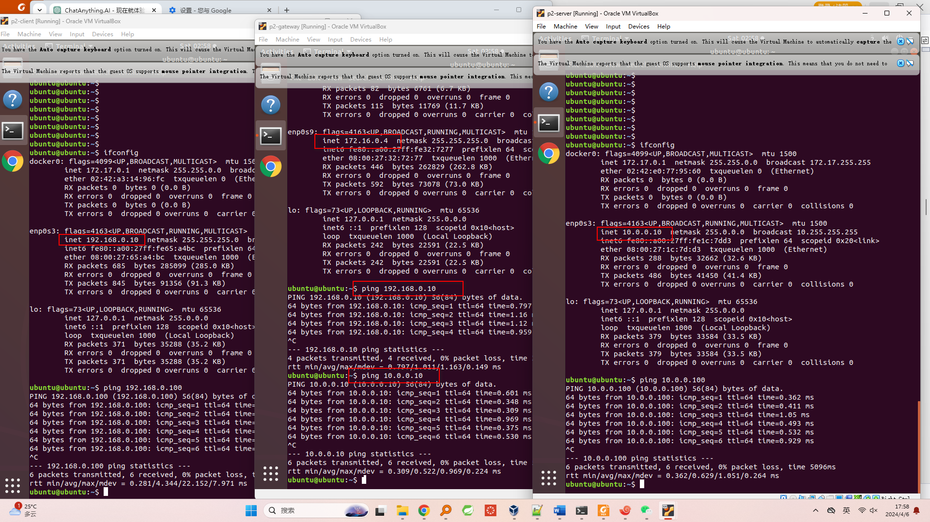

# 软件Software

列出完成本项目时你所用到的软件Describe major software and network services are used in this project to accomplish your goal.

Apache2，ssh，vsftp，防火墙脚本iptables，chrome，Ubuntu，nmap，vim，Oracle VM VirtualBox，notepad++，Linux网络工具ifconfig/route/ping等

# 项目描述Project Description

详细叙述你完成本项目的步骤，并给出佐证，如截图，配置文件等，以第一个项目为例，你需要在附录中附上你虚拟机中的netplan配置文件（netplan配置信息在附件中） Your work should have evidence and corresponding illustrations, e.g., providing configuration files as attachment in the appendix.

1. 任务 1 实验室环境的准备工作
2. 使用wget命令检查，发现wget和unzip已安装，但由于我的网络无法访问实验室文件的url，所以我从“项目 2 第一部分 Project 2 Part 1”作业的网页点击下载附上教程中需要下载的文件 lab-cs-cns-00001a.zip，并上传到<https://netcut.cn/>供虚拟机下载使用

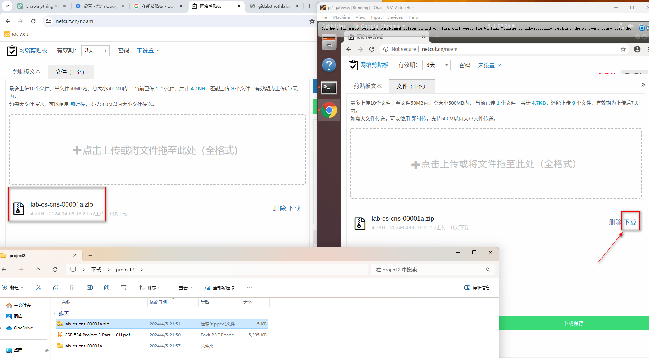

1. 使用uzip解压并使用chomd命令增加防火墙脚本执行权限，并执行防火墙脚本，由于防火墙脚本当前配置的是blacklist，所有所有虚拟机之间互相可以ping通。

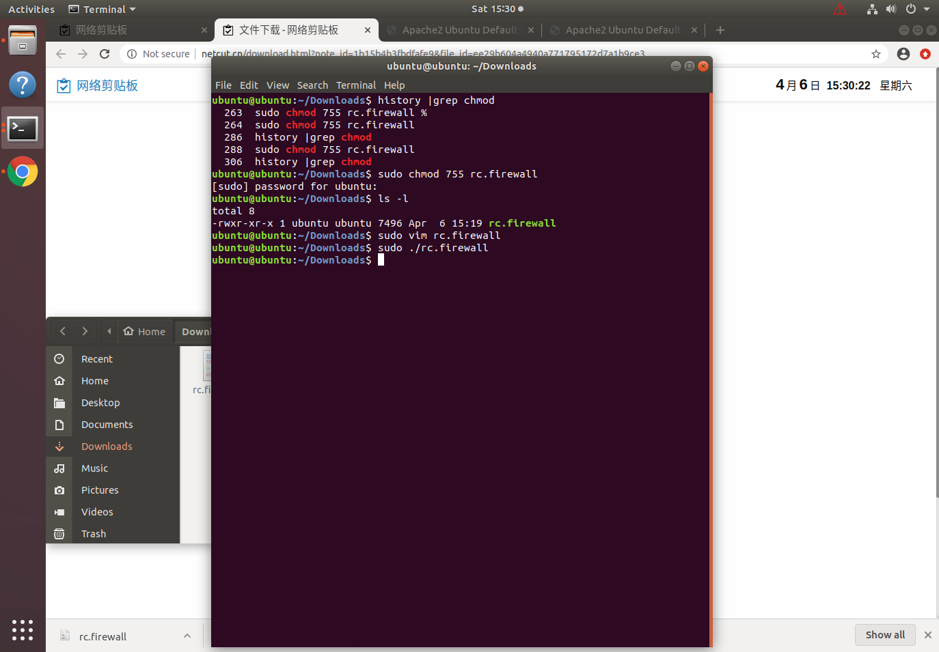

1. 1.1 任务 1.1 测试网络连接性
2. 参考项目一配置各个虚拟机的网卡（与项目一不同的是，我在VM BOX新增了NAT Network网段为172.16.0.0/12，并配置gateway的第三个网卡使用这个NAT Network）

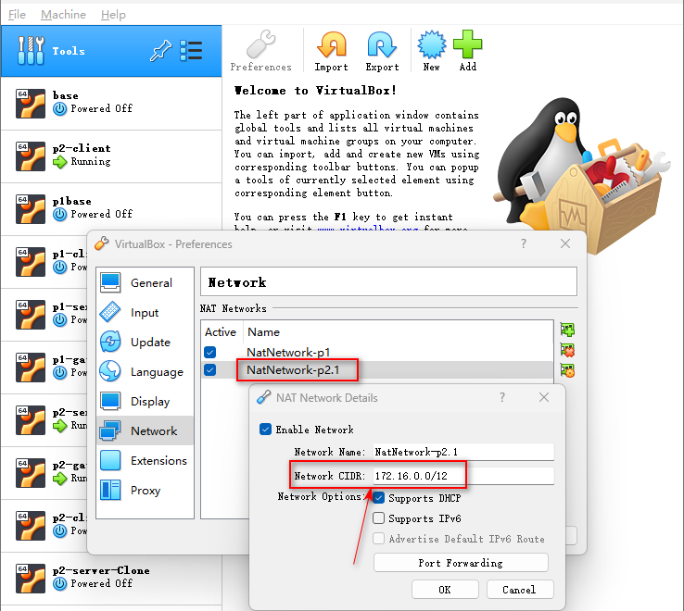

1. 使用 ping 检查连接（如果此步骤成功，请跳到任务 1.2）

* Client使用ifconfig检查ip和route配置，ping各个虚拟机和公网ip/dns

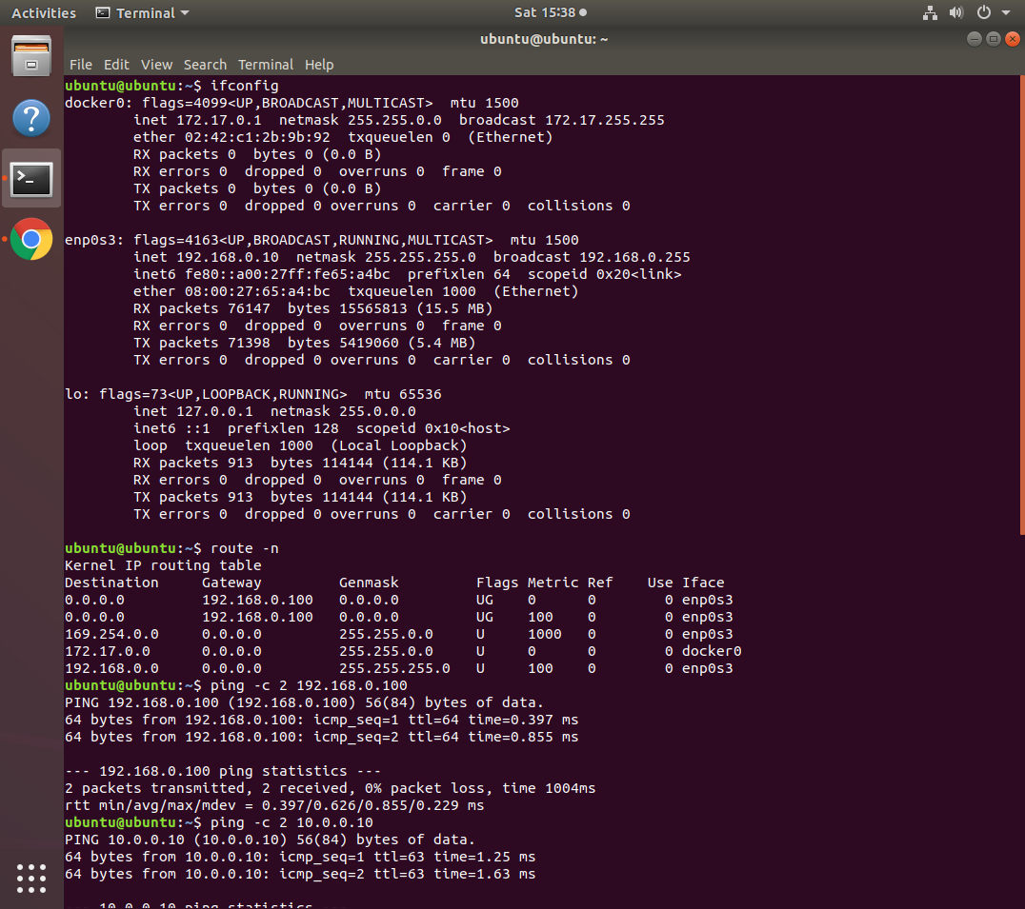

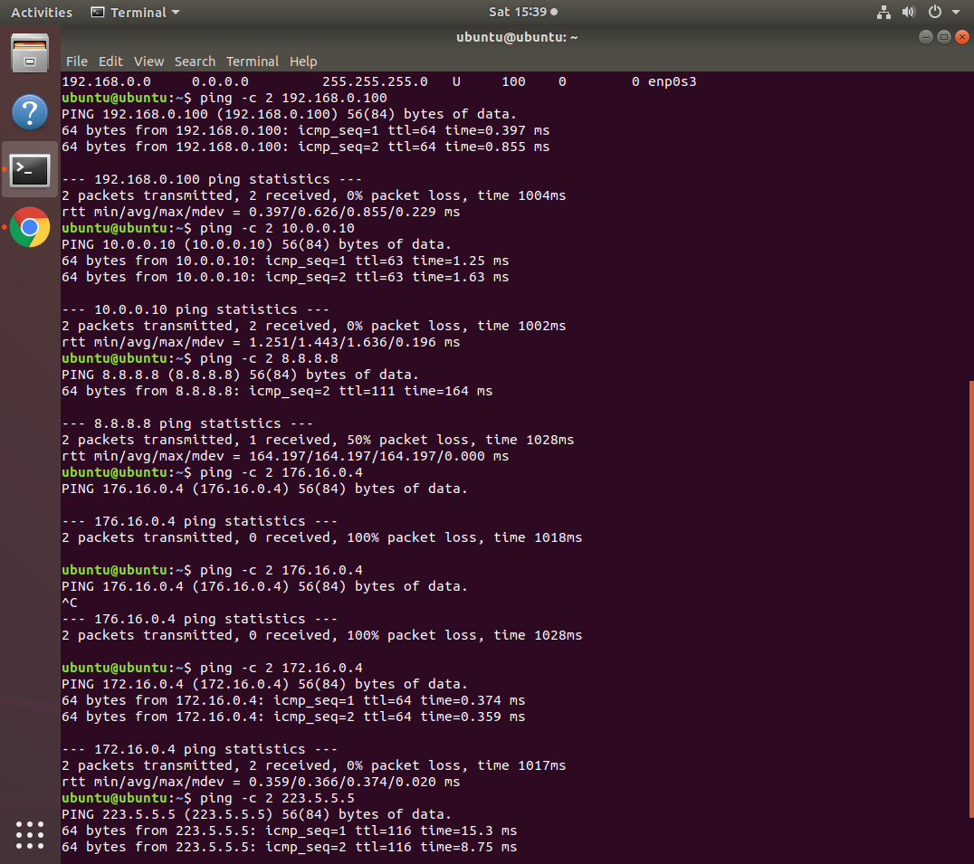

* Server使用ifconfig检查ip和route配置，ping各个虚拟机和公网ip/dns

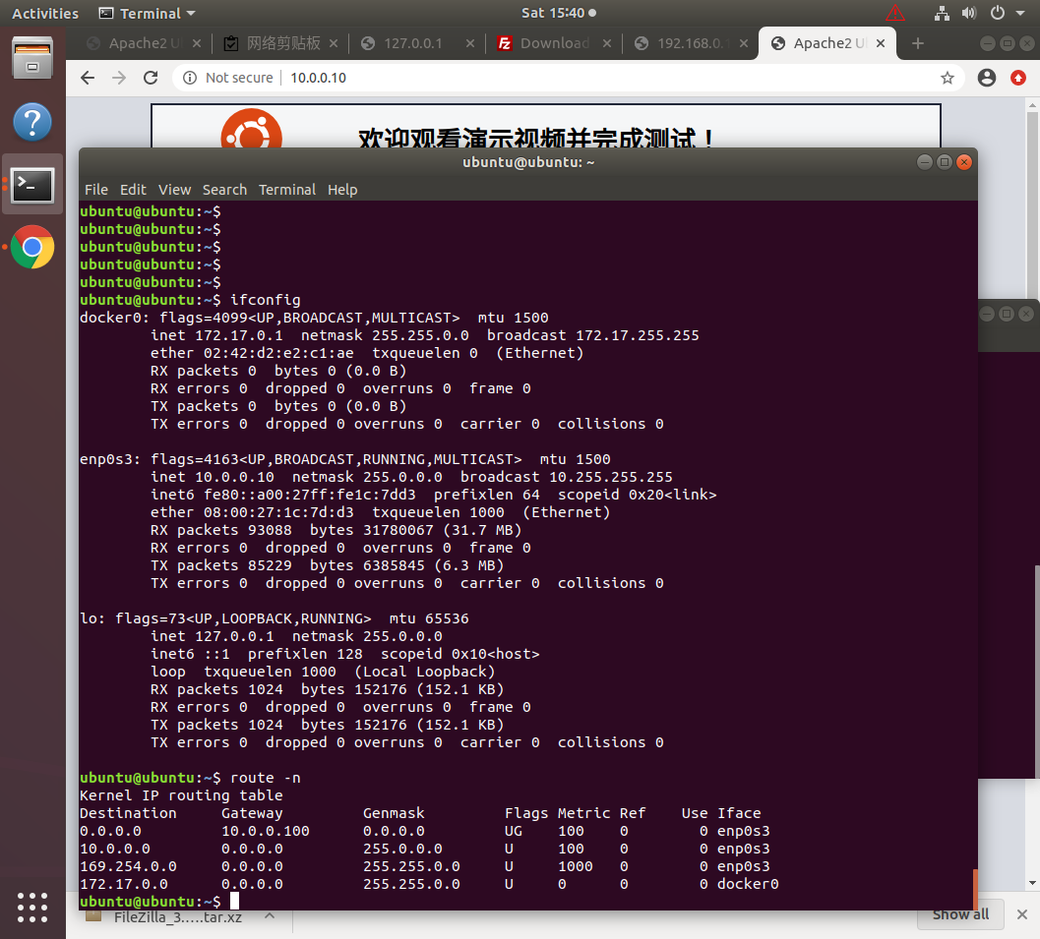

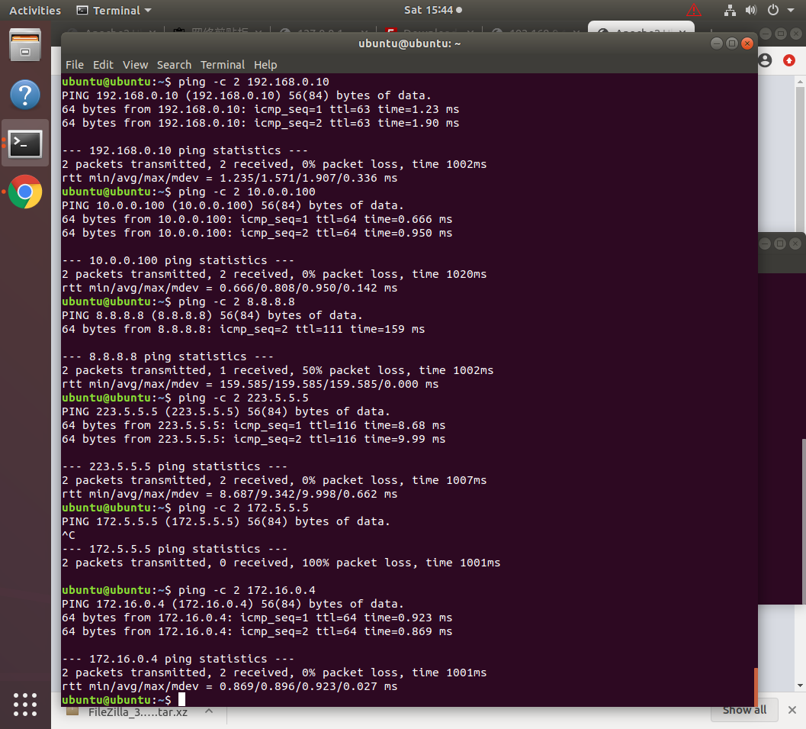

* Gateway使用ifconfig检查ip和route配置，ping各个虚拟机和公网ip/dns

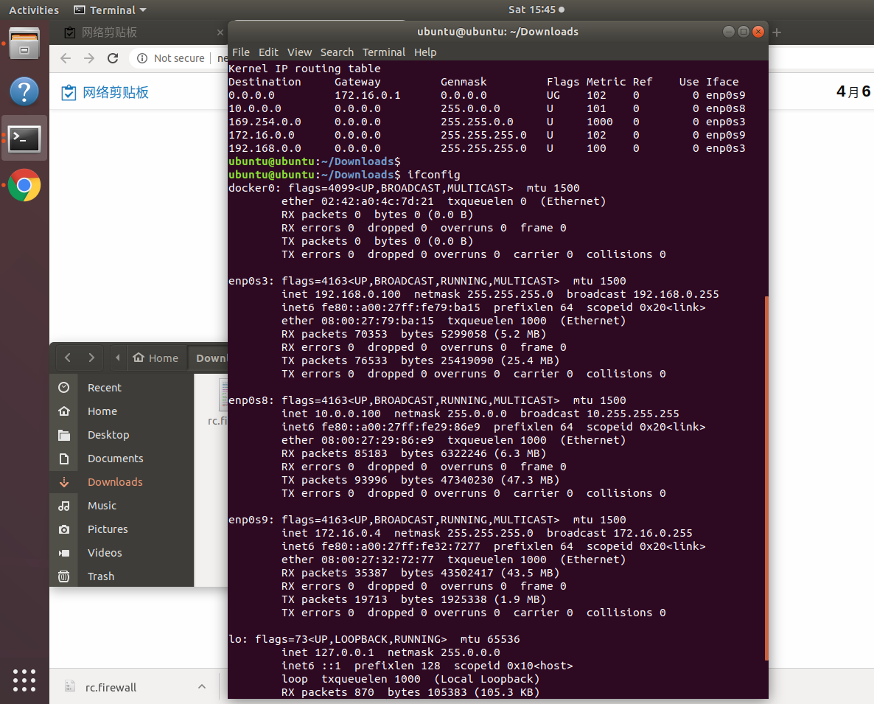

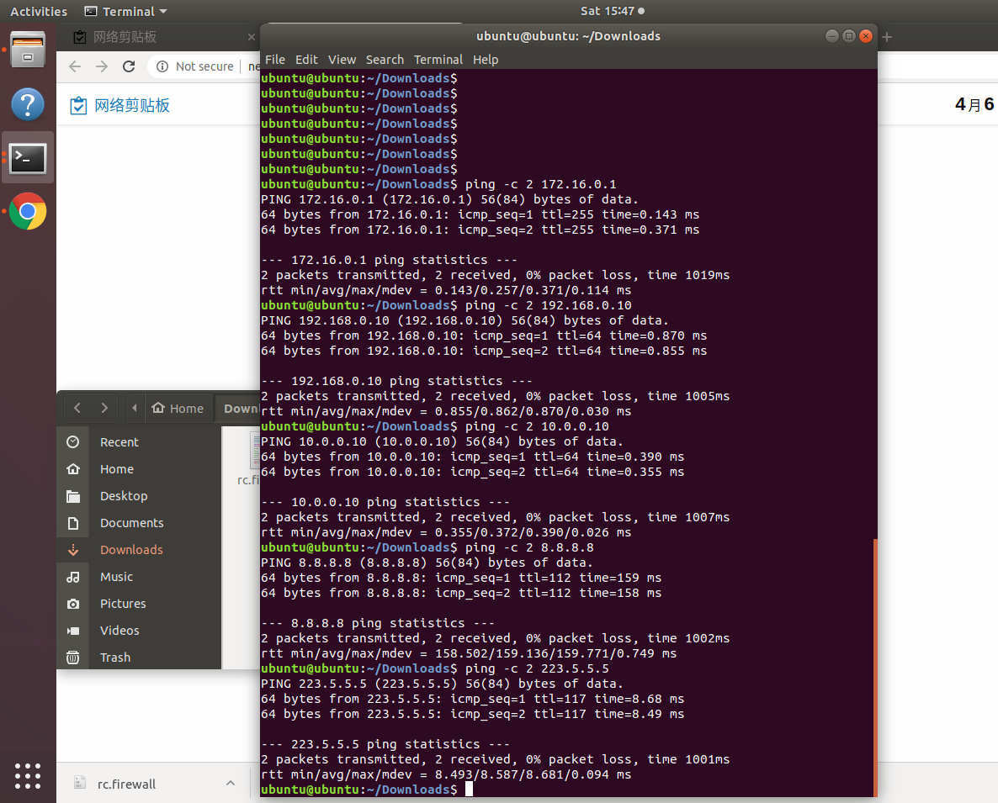

1. 由于服务器之间已能互相ping通，所以无需执行sudo ufw disable % 禁用防火墙，但我依然执行禁用防火墙；
2. 检查连通性后，你应该检查网关上的数据包转发设置，我查看到rc.firewall已经包含启用网关数据包转发配置，我直接执行sh命令是报错误的



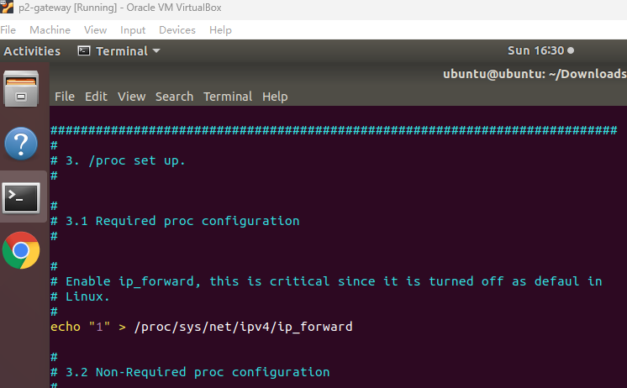

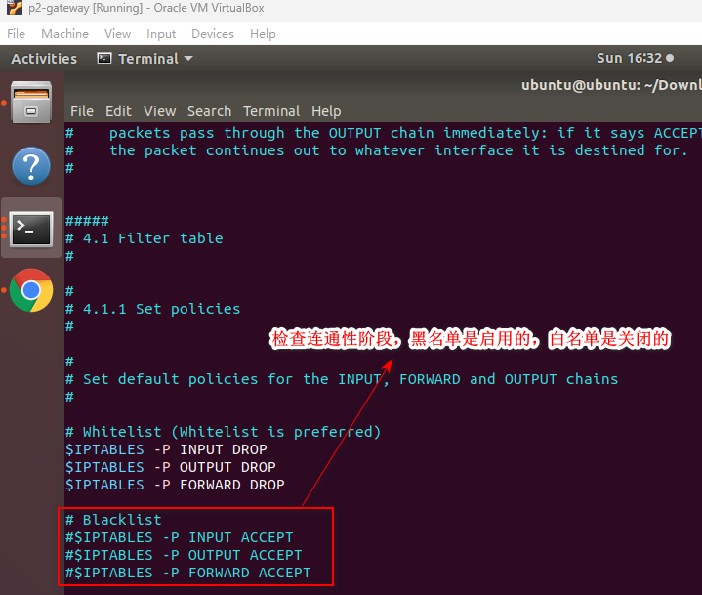

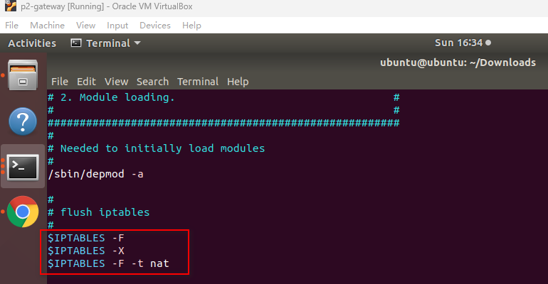

1. 任务 1.2 测试已安装的软件和服务
2. 在server端使用service命令检查，发现apache2已安装并启动，接下来是编辑文件 /var/www/html/index.html，将default page…信息替换为“欢迎观看演示视频…”

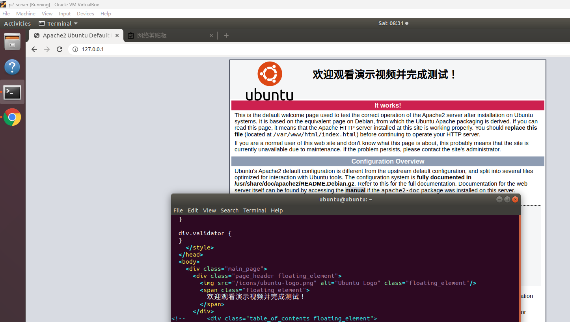

1. 在server端使用service命令检查，发现vsftpd未安装，更新源使用apt-get install vsftpd安装，安装成功并启动，配置被动端口模式和匿名登录，并在ftp的匿名用户目录下创建一个测试文件，匿名用户登录成功后，使用ls命令，能看见这个文件，再新增登录提示banner，并模拟登录验证效果

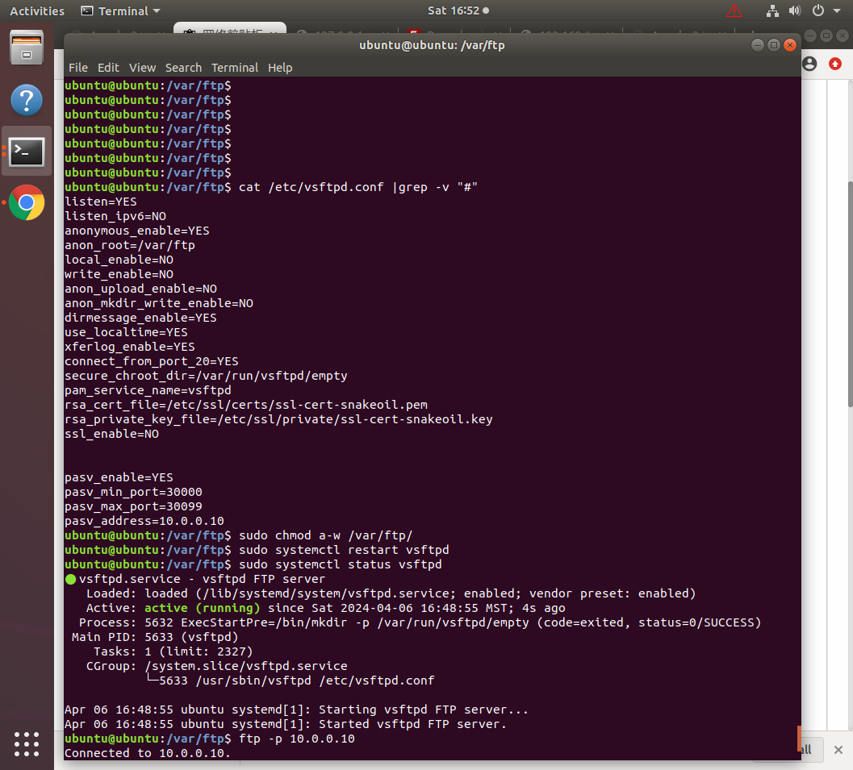

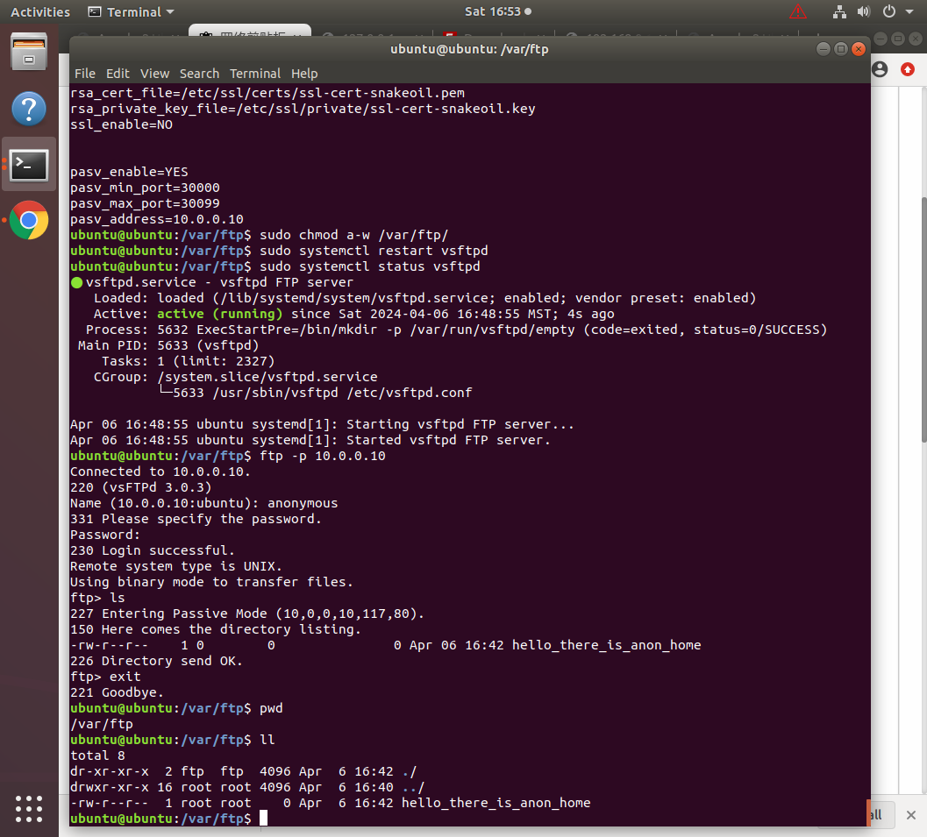

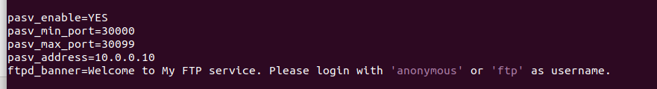

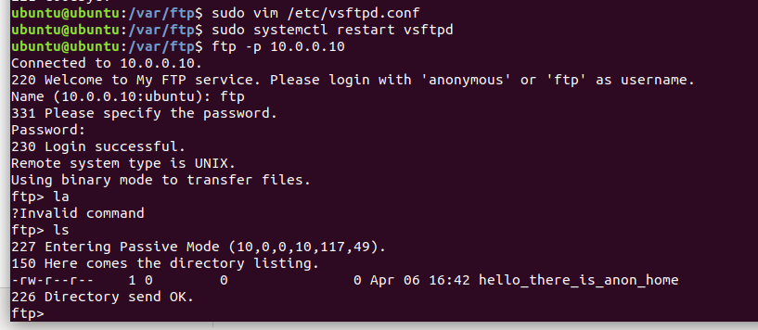

1. 在server端使用ssh连接自己是正常连接的

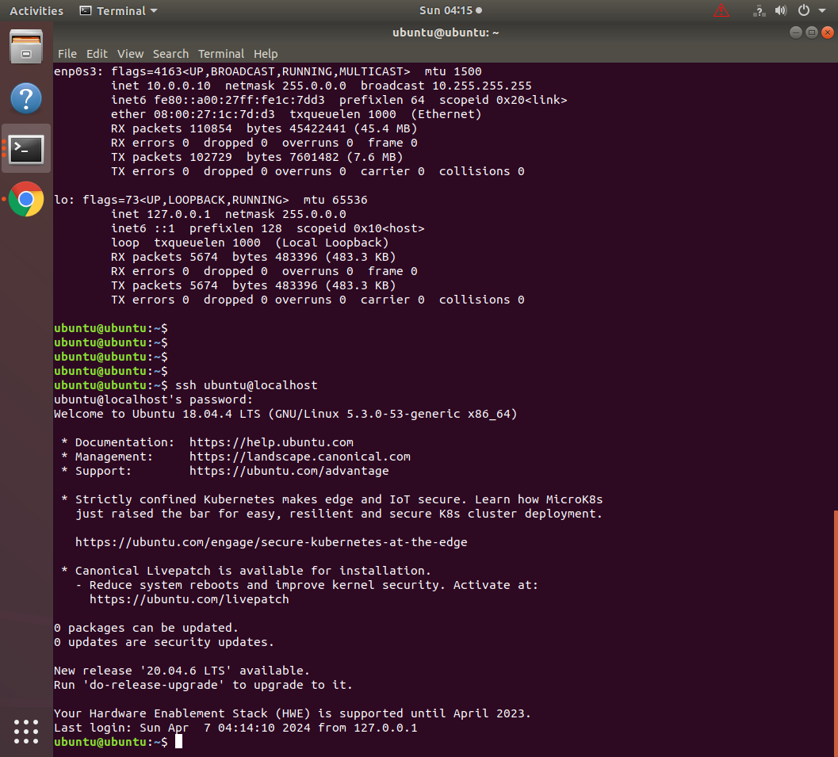

1. 任务 1.3 将防火墙重置为白名单
2. 防火墙脚本中已经有“清除 iptables 链并删除所有用户定义的链”的代码，将防火墙脚本的黑名单注释，打开白名单，也可以在gateway上直接命令行执行打开白名单

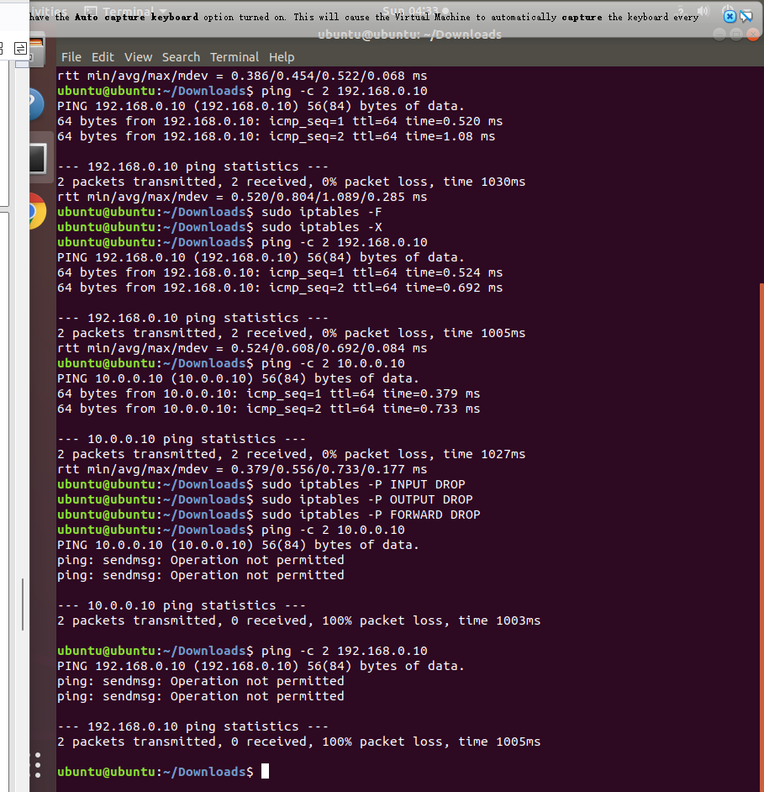

1. 打开白名单后，虚拟机之间不能执行 ping，也不能从客户端访问服务器托管的服务

* 将防火墙重置为白名单-客户端无法ping服务端/gateway和访问服务端80端口apache服务和21端口ftp服务

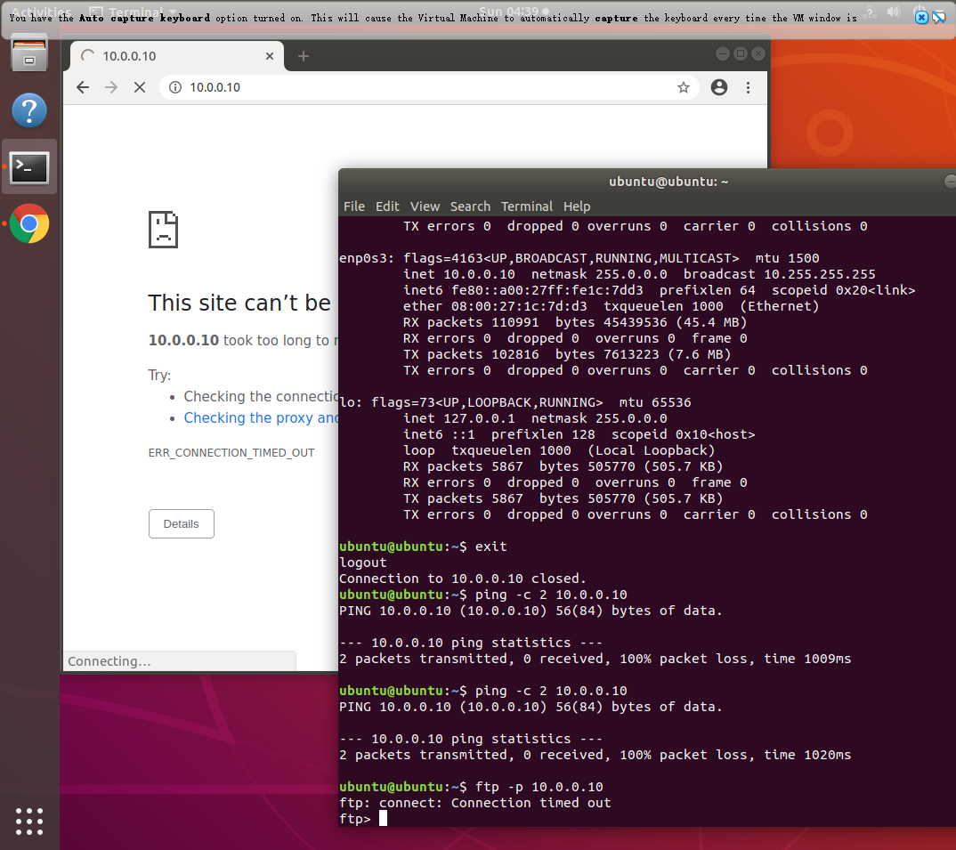

* 将防火墙重置为白名单-服务端无法ping客户端/gateway
* 将防火墙重置为白名单-gateway无法ping客户端/服务端

1. 任务 2 设置无状态数据包过滤防火墙的要求
2. 打开防火墙文件配置

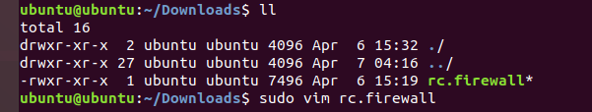

1. 配置端口转发

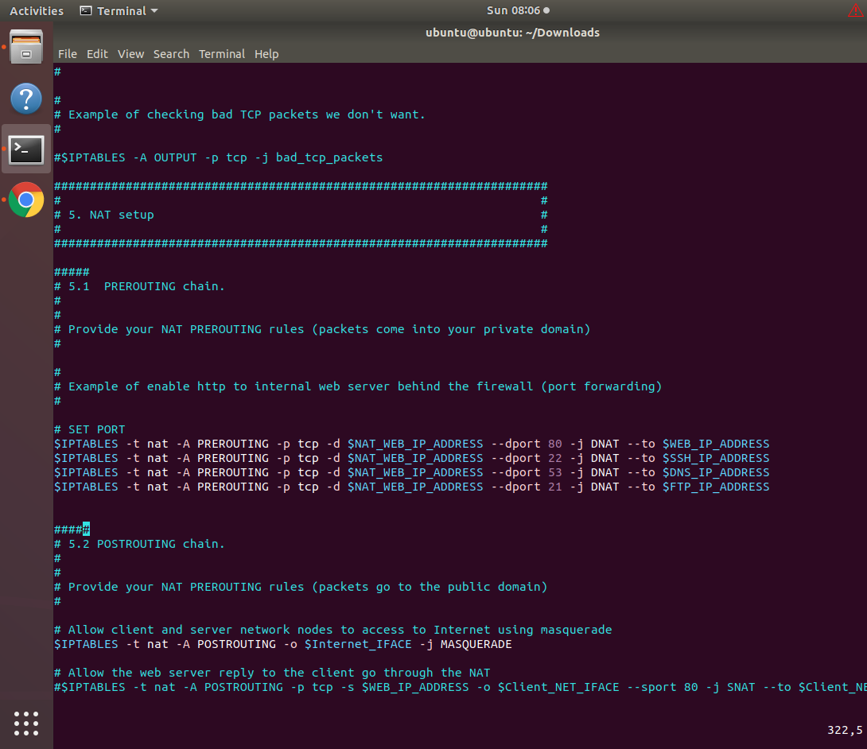

1. 在client访问gateway，请求能路由到server的端口，打开的apache2是server提供的，ssh登录的是server端，ftp连接的也是server端

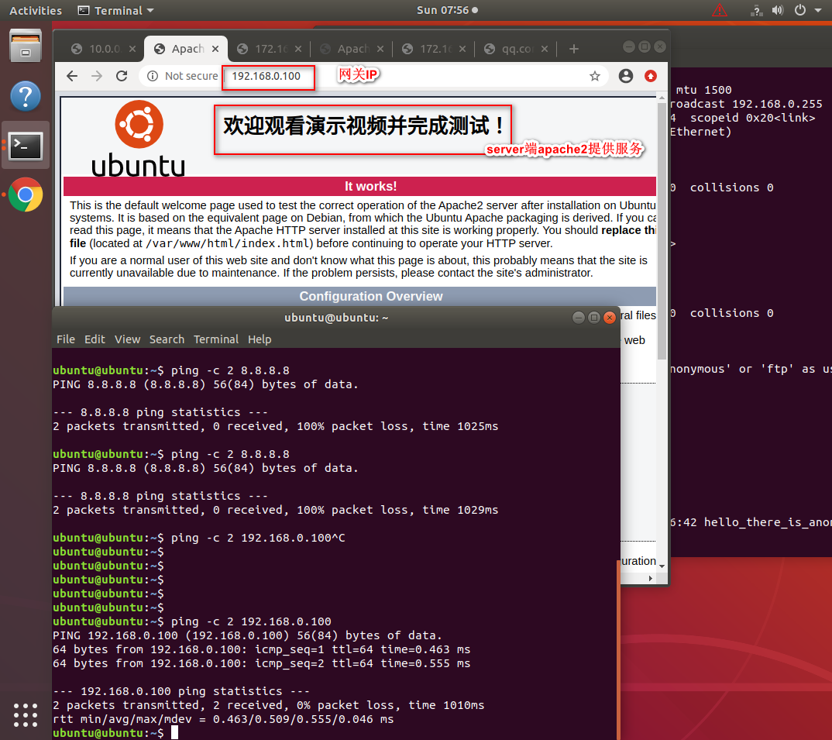

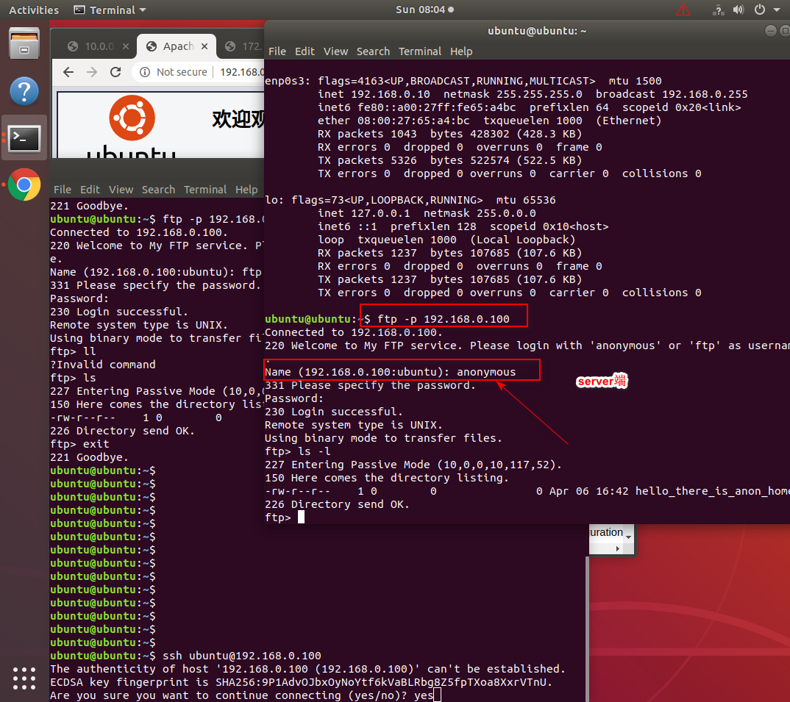

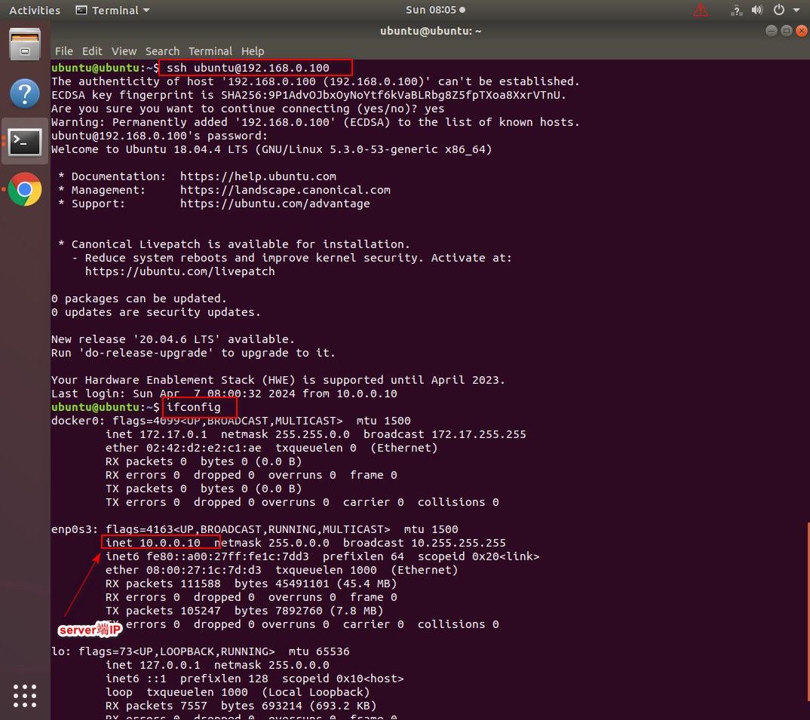

1. 允许客户端对网关的客户端一侧的 IP 地址执行 ping 。

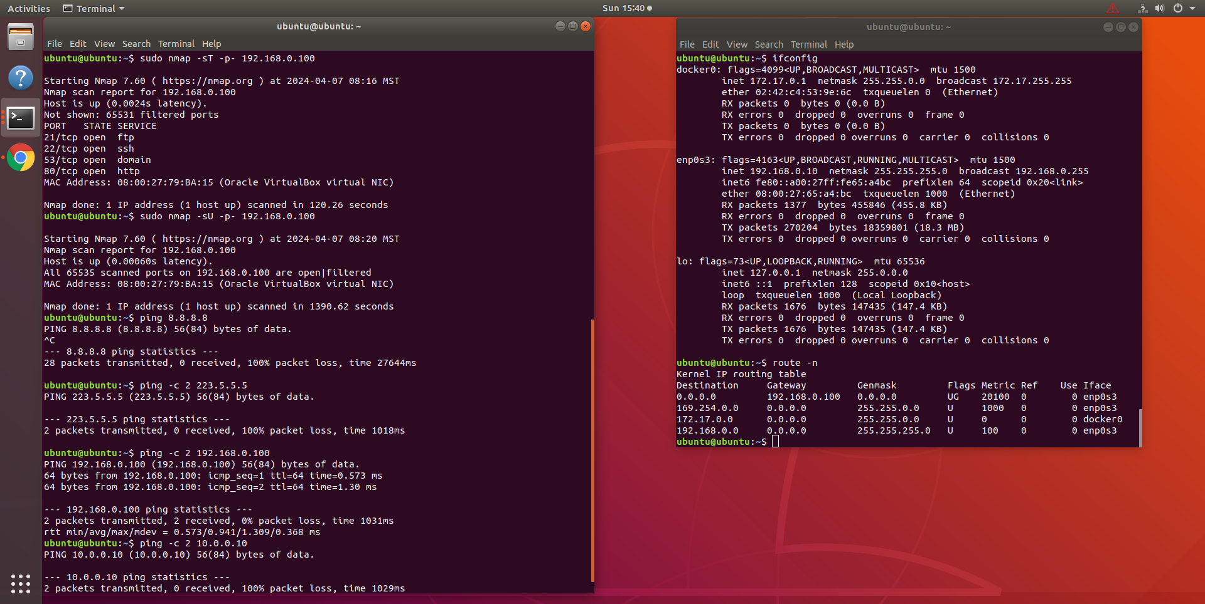

1. 允许服务器对网关的服务器端一侧的 IP 地址和客户端 IP 地址执行 ping。

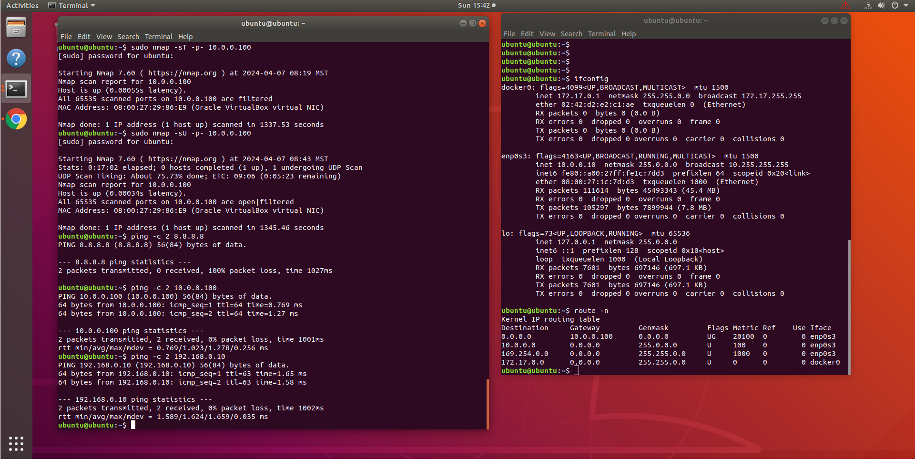

1. （5 分）附加要求
2. （5 分）附加要求
3. 在客户端虚拟机上执行命令



1. 在server端虚拟机上执行命令



1. 在gateway虚拟机执行命令

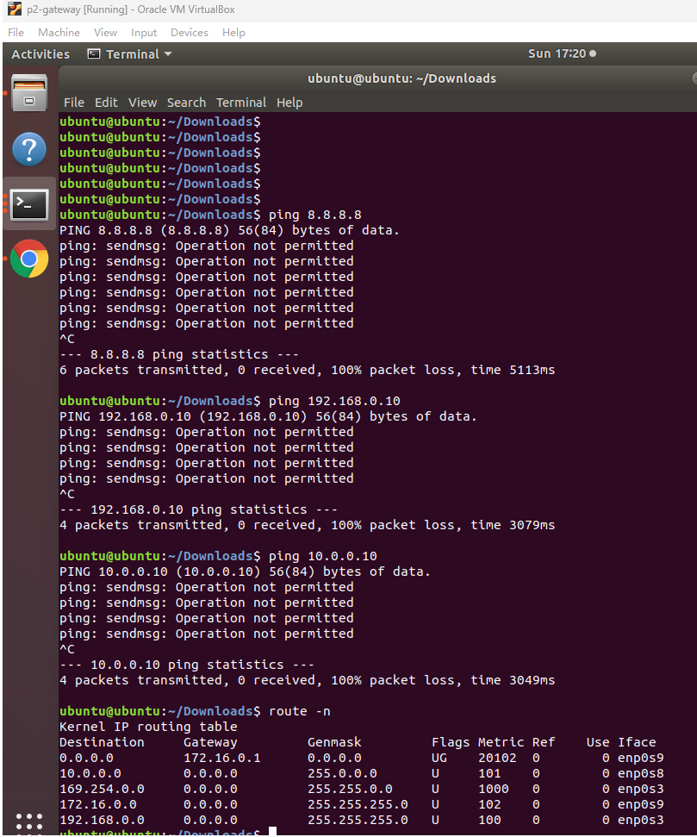

# 项目总结Conclusion

描述从这个项目中吸取的教训，例如，任何有趣的发现、提示和技巧。提供关于您的项目的自我评估，并为此项目提供评论。Describe lesson learned from this project, e.g., any interesting discovers, tips, and tricks. Provide a self-assessment about your project and provide comments to this project.

从本项目从学习到了如何搭建一套安全的与公网网络隔离的服务器集群，熟悉了配置网络防火墙的参数，包括端口转发，禁止/启用端口访问，禁止/启用ping功能，熟悉了nmap，apache，ftp等工具的基本使用。

# 附录：文件Appendix : Attached files

提供使用的配置和开发的源文件的列表。在您的配置文件中，请注明注释。一个好的做法是在您进行更改的地方提供注释，例如：

Provide a list of used configurations and developed source files. In your configuration file, please with well-marked comments. A good practice is to provide comments where you made changes, something like:

// Your Name: comments

# Your Name: comments

/*

Your Name: comments

*/

注释格式取决于您使用的系统文件和程序The comment format depends on your used system files and programs.

* 配置3台虚拟机ip和路由（见附件“配置3台虚拟机IP.txt”或如下配置netplan）



#********************************** client虚拟机上执行如下ssh配置命令 **********************************

#

sudo ifconfig enp0s3 192.168.0.10/24 netmask 255.255.255.0 up && sudo route add default gw 192.168.0.100 && route -n

sudo vim /etc/netplan/01-netcfg.yaml

# 01-netcfg.yaml 配置开始

network:

version: 2

renderer: networkd

ethernets:

enp0s3:

dhcp4: no

addresses:

- 192.168.0.10/24

gateway4: 192.168.0.100

nameservers:

addresses: [8.8.8.8,8.8.4.4]

# 01-netcfg.yaml 配置结束

sudo netplan apply

# 调试命令 sudo netplan -d apply

#********************************** server虚拟机上执行如下ssh配置命令 **********************************

#

sudo ifconfig enp0s3 10.0.0.10 netmask 255.0.0.0 up && sudo route add default gw 10.0.0.100 && route -n

sudo vim /etc/netplan/01-netcfg.yaml

# 01-netcfg.yaml 配置开始

network:

version: 2

renderer: networkd

ethernets:

enp0s3:

dhcp4: no

addresses:

- 10.0.0.10/8

gateway4: 10.0.0.100

nameservers:

addresses: [8.8.8.8,8.8.4.4]

# 01-netcfg.yaml 配置结束

sudo netplan apply

#********************************** gateway虚拟机上执行如下ssh配置命令 **********************************

#用于连接Client虚拟机网卡

sudo ifconfig enp0s3 192.168.0.100 netmask 255.255.255.0 up

#用于连接Server虚拟机网卡

sudo ifconfig enp0s8 10.0.0.100 netmask 255.0.0.0 up

#gateway虚拟机网卡，用于动态IP

sudo dhclient enp0s9

# 命令集合

sudo ifconfig enp0s3 192.168.0.100 netmask 255.255.255.0 up && sudo ifconfig enp0s8 10.0.0.100 netmask 255.0.0.0 up && sudo dhclient enp0s9 && route -n

sudo vim /etc/netplan/01-netcfg.yaml

# 01-netcfg.yaml 配置开始

network:

version: 2

renderer: networkd

ethernets:

enp0s3:

dhcp4: no

addresses:

- 192.168.0.100/24

nameservers:

addresses: [8.8.8.8,8.8.4.4]

enp0s9:

dhcp4: yes

nameservers:

addresses: [8.8.8.8,8.8.4.4]

enp0s8:

dhcp4: no

addresses:

- 10.0.0.100/8

nameservers:

addresses: [8.8.8.8,8.8.4.4]

# 01-netcfg.yaml 配置结束

sudo netplan apply

sudo iptables -t nat -A POSTROUTING -o enp0s9 -j MASQUERADE

sudo vim /etc/sysctl.conf

# 在打开的文件尾部追加配置

net.ipv4.ip_forward=1

sudo sysctl -p

* 附件是gateway的防火墙配置文件rc.firewall



#!/bin/sh

####

# 1.1. Internet ip address

#

#

Internet_IP="172.16.0.4"

Internet_IP_RANGE="172.16.0.0/12"

Internet_BCAST_ADRESS="172.31.255.255"

Internet_IFACE="enp0s9"

####

# 1.2 Client network configuration.

#

#

#

# IP addresses of the client-side network

#

Client_NET_IP="192.168.0.10"

Client_NET_IP_RANGE="192.168.0.0/24"

Client_NET_BCAST_ADRESS="192.168.0.255"

Client_NET_IFACE="enp0s3"

####

# 1.3 Server Network Configuration.

#

#

# IP addresses of the server-side network

#

Server_NET_IP="10.0.0.10"

Server_NET_IP_RANGE="10.0.0.0/8"

Server_NET_BCAST_ADRESS="10.255.255.255"

Server_NET_IFACE="enp0s8"

#

# IP aliases for the server (server's IP address)

#

LO_IFACE="lo"

LO_IP="127.0.0.1"

WEB_IP_ADDRESS="10.0.0.10"

MAIL_IP_ADDRESS="10.0.0.10"

SSH_IP_ADDRESS="10.0.0.10"

DNS_IP_ADDRESS="10.0.0.10"

FTP_IP_ADDRESS="10.0.0.10"

#IP aliases for NATed services (this is the GW's ip on client network)

NAT_WEB_IP_ADDRESS="192.168.0.100"

NAT_MAIL_IP_ADDRESS="192.168.0.100"

NAT_SSH_IP_ADDRESS="192.168.0.100"

NAT_DNS_IP_ADDRESS="192.168.0.100"

NAT_FTP_IP_ADDRESS="192.168.0.100"

PASV_FTP_PORT_RANGE="30000:30099"

####

# 1.4 IPTables Configuration.

#

IPTABLES="/sbin/iptables"

#######################################################

# #

# 2. Module loading. #

# #

#######################################################

#

# Needed to initially load modules

#

/sbin/depmod -a

#

# flush iptables

#

$IPTABLES -F

$IPTABLES -X

$IPTABLES -F -t nat

#####

# 2.1 Required modules

#

/sbin/modprobe ip_tables

/sbin/modprobe ip_conntrack

/sbin/modprobe iptable_filter

/sbin/modprobe iptable_mangle

/sbin/modprobe iptable_nat

/sbin/modprobe ipt_LOG

/sbin/modprobe ipt_limit

/sbin/modprobe ipt_state

#####

# 2.2 Non-frequently used modules

#

#/sbin/modprobe ipt_owner

#/sbin/modprobe ipt_REJECT

#/sbin/modprobe ipt_MASQUERADE

#/sbin/modprobe ip_conntrack_ftp

#/sbin/modprobe ip_conntrack_irc

#/sbin/modprobe ip_nat_ftp

###########################################################################

#

# 3. /proc set up.

#

#

# 3.1 Required proc configuration

#

#

# Enable ip_forward, this is critical since it is turned off as defaul in

# Linux.

#

echo "1" > /proc/sys/net/ipv4/ip_forward

#

# 3.2 Non-Required proc configuration

#

#

# Dynamic IP users:

#

#echo "1" > /proc/sys/net/ipv4/ip_dynaddr

###########################################################################

#

# 4. rules set up.

#

# The kernel starts with three lists of rules; these lists are called firewall

# chains or just chains. The three chains are called INPUT, OUTPUT and FORWARD.

#

# The chains are arranged like so:

#

# _____

# / \

# -->[Routing ]--->|FORWARD|------->

# [Decision] \_____/ ^

# | |

# v ____

# ___ / \

# / \ |OUTPUT|

# |INPUT| \____/

# \___/ ^

# | |

# ----> Local Process ----

#

# 1. When a packet comes in (say, through the Ethernet card) the kernel first

# looks at the destination of the packet: this is called `routing'.

# 2. If it's destined for this box, the packet passes downwards in the diagram,

# to the INPUT chain. If it passes this, any processes waiting for that

# packet will receive it.

# 3. Otherwise, if the kernel does not have forwarding enabled, or it doesn't

# know how to forward the packet, the packet is dropped. If forwarding is

# enabled, and the packet is destined for another network interface (if you

# have another one), then the packet goes rightwards on our diagram to the

# FORWARD chain. If it is ACCEPTed, it will be sent out.

# 4. Finally, a program running on the box can send network packets. These

# packets pass through the OUTPUT chain immediately: if it says ACCEPT, then

# the packet continues out to whatever interface it is destined for.

#

#####

# 4.1 Filter table

#

#

# 4.1.1 Set policies

#

#

# Set default policies for the INPUT, FORWARD and OUTPUT chains

#

# Whitelist (Whitelist is preferred)

$IPTABLES -P INPUT DROP

$IPTABLES -P OUTPUT DROP

$IPTABLES -P FORWARD DROP

# Blacklist

#$IPTABLES -P INPUT ACCEPT

#$IPTABLES -P OUTPUT ACCEPT

#$IPTABLES -P FORWARD ACCEPT

#

# 4.1.2 Create user-specified chains

#

#

# Example of creating a chain for bad tcp packets

#

#$IPTABLES -N bad_tcp_packets

#

# Create separate chains for allowed (whitelist), ICMP, TCP and UDP to traverse

#

#$IPTABLES -N allowed

#$IPTABLES -N tcp_packets

#$IPTABLES -N udp_packets

#$IPTABLES -N icmp_packets

# 开启client ping网关和server ping client与网关server

$IPTABLES -A INPUT -p icmp --icmp-type echo-request -s $Client_NET_IP -d $NAT_WEB_IP_ADDRESS -j ACCEPT

$IPTABLES -A OUTPUT -p icmp --icmp-type echo-reply -s $NAT_WEB_IP_ADDRESS -d $Client_NET_IP -j ACCEPT

$IPTABLES -A INPUT -p icmp --icmp-type echo-request -s $Server_NET_IP -d $Server_NET_IP_RANGE -j ACCEPT

$IPTABLES -A OUTPUT -p icmp --icmp-type echo-reply -s $Server_NET_IP_RANGE -d $Server_NET_IP -j ACCEPT

$IPTABLES -A FORWARD -p icmp --icmp-type echo-request -s $Server_NET_IP -d $Client_NET_IP_RANGE -j ACCEPT

$IPTABLES -A FORWARD -p icmp --icmp-type echo-reply -s $Client_NET_IP_RANGE -d $Server_NET_IP -j ACCEPT

#

# In the following 4.1.x, you can provide individual user-specified rules

#

# 4.1.3 Example of create content in user-specified chains (bad_tcp_packets)

#

#

# bad_tcp_packets chain

#

#$IPTABLES -A bad_tcp_packets -p tcp --tcp-flags SYN,ACK SYN,ACK -m state --state NEW -j REJECT --reject-with tcp-reset

#$IPTABLES -A bad_tcp_packets -p tcp ! --syn -m state --state NEW -j LOG --log-prefix "New not syn:"

#$IPTABLES -A bad_tcp_packets -p tcp ! --syn -m state --state NEW -j DROP

#

# 4.1.4 Example of allowed chain (allow packets for initial TCP or already established TCP sessions)

#

#$IPTABLES -A allowed -p TCP --syn -j ACCEPT

#$IPTABLES -A allowed -p TCP -m state --state ESTABLISHED,RELATED -j ACCEPT

#$IPTABLES -A allowed -p TCP -j DROP

#####

# 4.2 FORWARD chain

#

#

# Provide your forwarding rules below

#

# example of checking bad tcp packets

#$IPTABLES -A FORWARD -p tcp -j bad_tcp_packets

# Allow http traffic from client network to server network

$IPTABLES -A FORWARD -p TCP --dport 80 -i $Client_NET_IFACE -s $Client_NET_IP_RANGE -d $WEB_IP_ADDRESS -j ACCEPT

$IPTABLES -A FORWARD -p TCP --sport 80 -i $Server_NET_IFACE -s $WEB_IP_ADDRESS -d $Client_NET_IP_RANGE -j ACCEPT

$IPTABLES -A FORWARD -p TCP --dport 22 -i $Client_NET_IFACE -s $Client_NET_IP_RANGE -d $SSH_IP_ADDRESS -j ACCEPT

$IPTABLES -A FORWARD -p TCP --sport 22 -i $Server_NET_IFACE -s $SSH_IP_ADDRESS -d $Client_NET_IP_RANGE -j ACCEPT

$IPTABLES -A FORWARD -p TCP --dport 53 -i $Client_NET_IFACE -s $Client_NET_IP_RANGE -d $DNS_IP_ADDRESS -j ACCEPT

$IPTABLES -A FORWARD -p TCP --sport 53 -i $Server_NET_IFACE -s $DNS_IP_ADDRESS -d $Client_NET_IP_RANGE -j ACCEPT

$IPTABLES -A FORWARD -p TCP --dport 21 -i $Client_NET_IFACE -s $Client_NET_IP_RANGE -d $FTP_IP_ADDRESS -j ACCEPT

$IPTABLES -A FORWARD -p TCP --sport 21 -i $Server_NET_IFACE -s $FTP_IP_ADDRESS -d $Client_NET_IP_RANGE -j ACCEPT

$IPTABLES -A FORWARD -p TCP --dport 30000:30099 -i $Client_NET_IFACE -s $Client_NET_IP_RANGE -d $FTP_IP_ADDRESS -j ACCEPT

$IPTABLES -A FORWARD -p TCP --sport 30000:30099 -i $Server_NET_IFACE -s $FTP_IP_ADDRESS -d $Client_NET_IP_RANGE -j ACCEPT

# example of using allowed

#$IPTABLES -A FORWARD -p tcp -j allowed

#####

# 4.3 INPUT chain

#

#

# Provide your input rules below

#

#

# Example of checking bad TCP packets we don't want.

#

#$IPTABLES -A INPUT -p tcp -j bad_tcp_packets

#####

# 4.3 OUTPUT chain

#

#

# Provide your output rules below

#

#

# Example of checking bad TCP packets we don't want.

#

#$IPTABLES -A OUTPUT -p tcp -j bad_tcp_packets

#####################################################################

# #

# 5. NAT setup #

# #

#####################################################################

#####

# 5.1 PREROUTING chain.

#

#

# Provide your NAT PREROUTING rules (packets come into your private domain)

#

#

# Example of enable http to internal web server behind the firewall (port forwarding)

# 端口转发，访问gateway的指定端口的请求路由到server的该端口上

# SET PORT

$IPTABLES -t nat -A PREROUTING -p tcp -d $NAT_WEB_IP_ADDRESS --dport 80 -j DNAT --to $WEB_IP_ADDRESS

$IPTABLES -t nat -A PREROUTING -p tcp -d $NAT_WEB_IP_ADDRESS --dport 22 -j DNAT --to $SSH_IP_ADDRESS

$IPTABLES -t nat -A PREROUTING -p tcp -d $NAT_WEB_IP_ADDRESS --dport 53 -j DNAT --to $DNS_IP_ADDRESS

$IPTABLES -t nat -A PREROUTING -p tcp -d $NAT_WEB_IP_ADDRESS --dport 21 -j DNAT --to $FTP_IP_ADDRESS

#####

# 5.2 POSTROUTING chain.

#

#

# Provide your NAT PREROUTING rules (packets go to the public domain)

#

# Allow client and server network nodes to access to Internet using masquerade

$IPTABLES -t nat -A POSTROUTING -o $Internet_IFACE -j MASQUERADE

# Allow the web server reply to the client go through the NAT

#$IPTABLES -t nat -A POSTROUTING -p tcp -s $WEB_IP_ADDRESS -o $Client_NET_IFACE --sport 80 -j SNAT --to $Client_NET_IP

# 参考References

参考是可选的，可以向阅读你的报告提供链接源以进行验证和学习。Reference is optional, but nice to have to allow others to read your report with additional linked source for validation and learning.

1. Wireshark, available at <https://www.wireshark.org/>, accessed by 8/31/2018.
2. Postel, Jon. "RFC 791: Internet protocol." (1981).